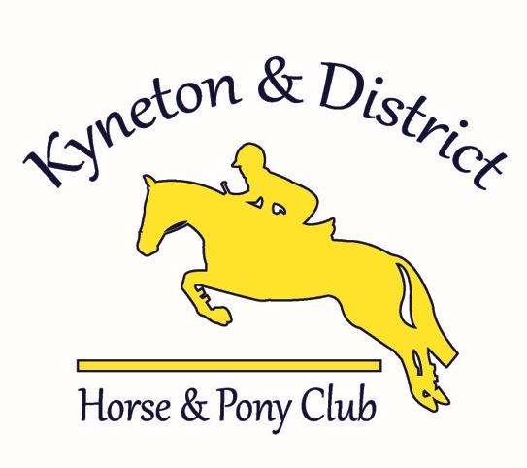

Code of Conduct
PCAV Code of Conduct 2010

The Pony Club Association of Victoria’s Code of Conduct outlines behaviours that are expected of every person involved in our organisation, as well as identifying the types of behaviours that will not be tolerated.
It applies to members, officials, adult supporters, coaches, instructors, spectators, family, friends, administrators and other members of our diverse pony club community. It applies to all PCAV, Zone and Club sanctioned activities.
The Pony Club Association of Victoria’s Code of Conduct supports everyone to have fun in a friendly and inclusive environment.

Our Values and Behaviours

Respect and Recognition
- I will treat others as I would like to be treated
- I will treat everyone with dignity, courtesy and respect
- I will appreciate performances by all participants
- I will value and recognise good behaviours and the contribution of all
- I will communicate openly and provide constructive supportive feedback

Caring
- The welfare of the horse is paramount
- I will be considerate of others
- I will encourage others to participate but I won’t force the issue
- I will never resort to verbal abuse, harassing behaviour, hostility or aggression

Integrity
- I will be open, honest and trustworthy
- I will do what I say
- I will be a Good Sport and encourage others to do the same
- I will not make any disparaging or belittling remarks about others
- I will abide by the Code of Conduct

Inclusion
- I will support and help others
- I will be flexible and responsive to people’s needs
- I will work collaboratively to achieve the best outcomes
- I will encourage the participation of all regardless of ability, age, gender, sexual orientation, race, culture or religion
- I will contribute towards an enjoyable and safe environment for all

